CSA1411-COMPILER DESIGN

LAB EXPERIMENTS

NAME:- R KALAI AMUDHAN

REG NO:- 192511292

EXPERIMENT – 14:
AIM:-
Implement the concept of Shift reduce parsing in C Programming.
CODE:-
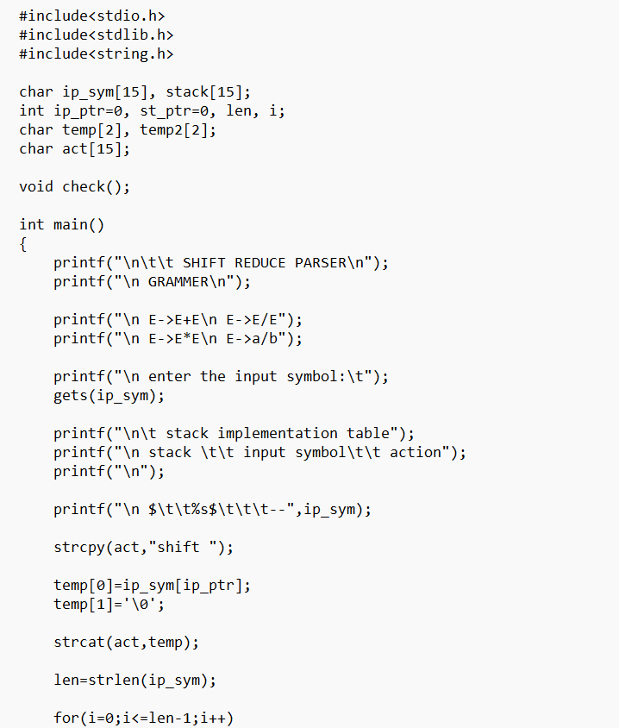
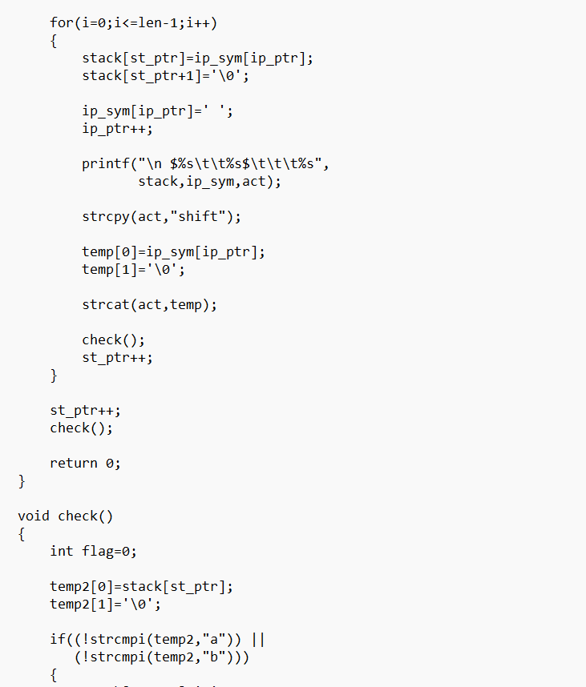
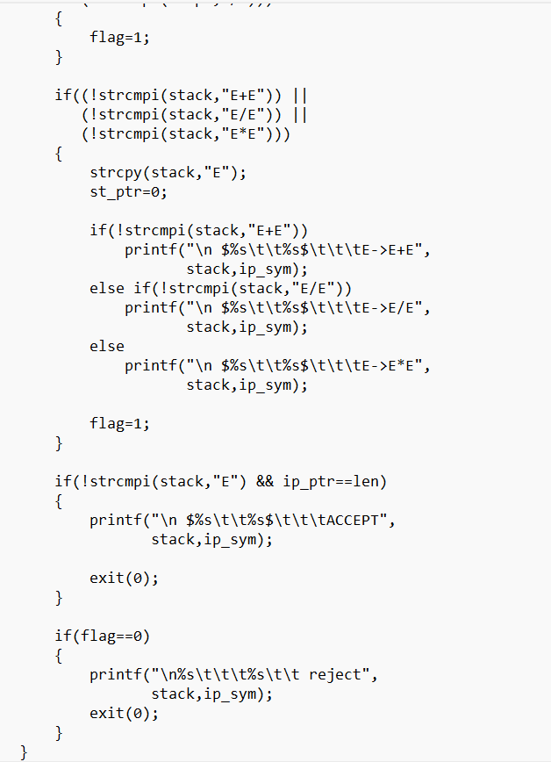
OUTPUT:-
